TSERS ONLINE RETIREMENT APPLICATION PROCESS

Eligibility:

For Full Retirement:
- at age 65 with 5 years of service
- at the age of 60 with 25 years of service, or
- at any age with 30 years of service

For Reduced Retirement:
- at age 60 with 5 years of service
- at the age of 50 with 20 years of service
Eligibility for Retiree Health Coverage
- If you were first hired prior to October 1, 2006, and retire with 5 or more years of contributory retirement service, you will be eligible for health care coverage at no cost, under certain plan options
- If you were first hired on or after October 1, 2006 you must retire with 20 years of retirement service credit to receive health care coverage at no cost, under certain plan options. However, if you have at least 10 but less than 20 years of retirement service credit, you are eligible for coverage, but you will pay 50% of the cost of coverage. If you have at least 5 years of contributory retirement service, but less than 10 years of retirement service credit, you are eligible for coverage, but you will pay 100% of the cost of coverage.
- If you were hired on or after January 1, 2021, you will not be eligible to receive retiree medical benefits.
Medicare
- Important Medicare Information: When you are eligible for Medicare upon retirement, you must enroll in both Part A and B in order to maintain the same level of coverage received prior to retirement. If you are Medicare Eligible you will need to ensure that Medicare A & B is setup as of your effective retirement date. It is recommended to apply 3 months prior to your retirement effective date.
- The cost of Medicare Part B is based on your salary. To confirm the cost of Medicare Part B, please contact the Social Security Administration at 800-772-1213 or www.socialsecurity.gov
Steps for online retirement
- Log into the Orbit site: https://orbit.myncretirement.com/
- Key in your ‘User Name’ and ‘Password’.
- If you have forgotten your username or password, please use the “Forgot” links to obtain and/or update your account access information.
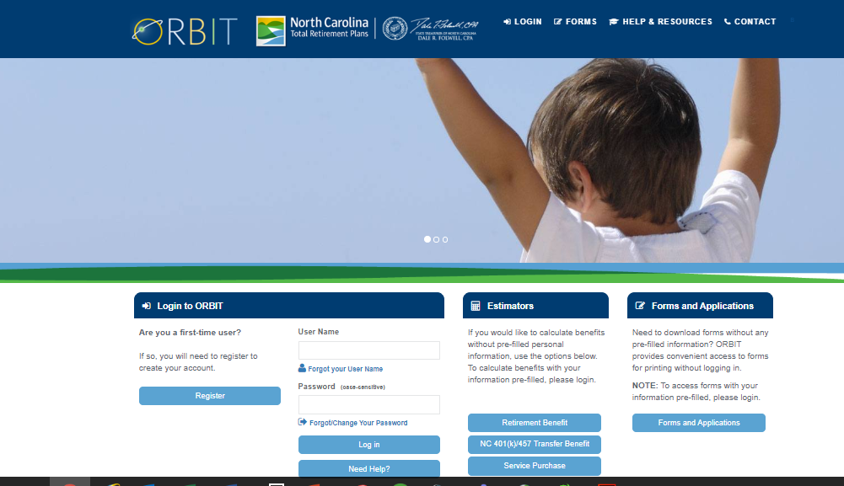
- Once logged in, you will be prompted to authenticate your access.
- After successful authentication, you will be directed to your account home page.
- Click on ‘Apply for Retirement Online’, located in the left light blue scroll bar.
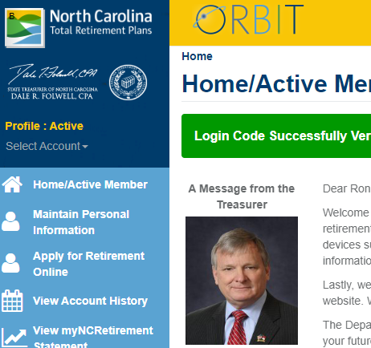
- After clicking on link, you will be directed to the retirement resource page.
- Feel free to review the different available resources and links on the page.
- However, to begin the application process, click on the ‘Get Started’ green radio button located at the bottom right of the page.
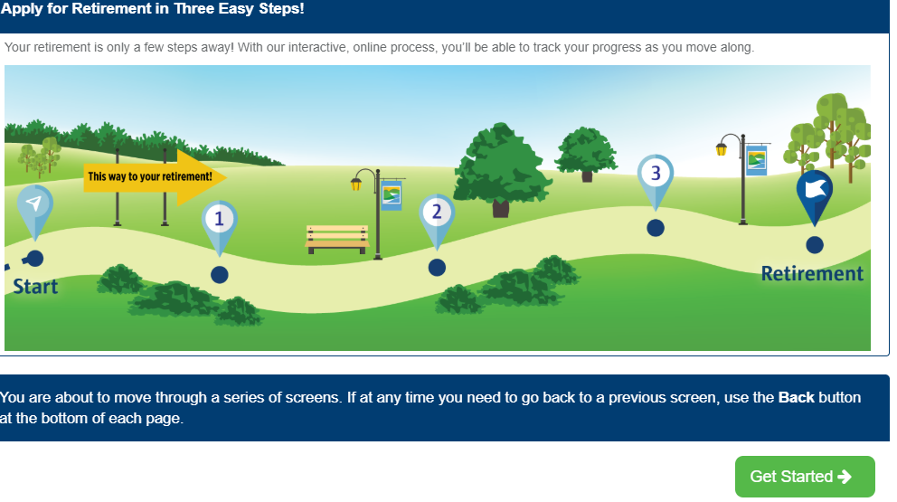
- After clicking on ‘Get Started’, you will enter into the application process.
- From this point on you will enter information needed to complete the employee portion of the retirement application process.
- Please note: Some information will be auto populated based on your last work record. All applicants are encouraged to verify all information is correct.
- Below are just some of the various questions you are asked when completing your TSERS application:
  - Personal Information: Name, Social Security Number, Member ID (also referred to as ORBIT ID), Contact Information, and Date of Birth
  - Work Information: Last employer, last position held, and projected Last Day Worked (Note: If using leave prior to retirement, your last date work is your termination date)
  - Effective Retirement Date: All effective dates of retirement must be the first of a month
  - Beneficiary Information
- After you have entered and verified all information on each page, click the ‘Save and continue’ () green radio button located at the bottom, right of each page to continue to the next section until you have navigated to the end of the application process.
- The system will verify any missing information needed before it will allow you to move onto the next page/section of the application.
- Once all information is verified, the NC-RSD will send your employer notification of the completed online retirement application. The University Benefits Administrator (UBA) will complete and submit all employer information back to the NC-RSD. The UBA will also follow-up with you after completing the employer section of the retirement application to advise what you can expect next.
Need Assistance:
For online application assistance please contact the NC-RSD at 877-627-3287.

